Session overview
- Part I: Setting a Foundation (20’)
- Part II: Hearing from College Instructors across the Disciplines (50’ + 15’ response)
- Part III: Exploring Ways to Bridge the Gap (25’)
- Part IV: Collecting Ideas about a Specific Gap: Literacy around Research (30’)

Part I: Foundation Building Question Guide
- What SKILLS do you currently teach that you believe contribute most to your students’ ability to read and write at the college level?

- What HABITS OF MIND do you currently develop that you believe contribute most to your students’ ability to read and write at the college level?

- What NON-CLASS OPPORTUNITIES do you provide for students to develop identities that may contribute to their reading/writing success at college?

- What SKILLS or HABITS OF MIND do you think that college instructors feel are least developed among their incoming students?

Part I Table Discussions.
At your tables, discuss your individual answers. Where do you see overlap? Where do you see points of diversion? Successes? Points of confusion?

Also, what do you predict the guest panelists might say about their perceptions of students’ reading/writing preparedness? From this discussion, what are some questions you might want to ask of the guest panelists?

Part II. Notes on guest panel
- Steve Barrett, College of Engineering
- Brianna Wright, Life Sciences
- Joyce Stewart, First-Year Composition
- Scott Freng/Sean McCrea, Psychology
- Melissa Bowles-Terry, Honors Program/Library instruction

Part II. Table discussions after the panelists speak
What matched your expectations?

What did you hear that surprised you?

Where do you want more clarification?

Part III. Responding to the Gap

There are, potentially, many different ways to think about “filling” the gap between high school and college. In the literature, a few of the most common are the following.

Increasing “articulation” between high schools and colleges:
Strategy 1: Through increased COMMUNICATION.

Strategy 2: Through increased information about SKILLS.

Strategy 3: Through increased awareness of relevant HABITS of MIND.

Strategy 4: Increasing training in methods of “TEACHING for TRANSFER.”

Strategy 5: Acknowledging and appreciating that there may be necessary and appropriate disconnects between what happens in high school and what happens in college.

Strategy 1: Facilitating transfer by increasing communication between high school and college faculty
- View the college-level prompts in the other handout (also available online here: bit.ly/QelBxQ
- Consider attending Teaching Writing in Wyoming:
In addition to follow-up discussion about last year’s meeting on transfer of learning, the next annual Teaching Writing in Wyoming conference (April 7-8 in Casper, WY) will focus largely on strategies for teaching research literacies: how can teachers (especially grades 7-12) develop assignments, units, projects, and collaborations that promote students’ deep engagement with content while also encouraging ethical, critical, and broad use of sources?
- Plan professional development and curricular change based on dialogue with college faculty. The following plan is from Lander Valley High School and emerged from their dialogue with CWC and UW.
Make instructional changes to LA 12
- Focus on expository
  - claim, evidence, analysis
  - synthesis
  - writing densely
  - transition sentences
- Personal narratives moved to start of year and small assignments throughout
  - great for understanding students and building rapport
  - not so great for college prep
  - therapy - writing as psychological control
- Talking about college writing in all senior English classes
  - building upon the foundations already established by previous Eng. teachers
  - discussing the role that “instructor preference” plays in adjusting writing tone, style, and format
  - strongly encouraging students to visit writing centers
Provide education/PD for staff about writing
- Common Core
- Required Skills
  - 6-Trait Writing
  - Organization/Format (The Basics, Persuasive, Compare/Contrast)
  - Analytical Response Format (Claim, Evidence, Analysis)
  - Teaching Summary Writing
  - Teaching Vocabulary
  - Effective Use of Rubrics
  - Annotating/Reciprocal Reading
- Common Vernacular
Build an expectation for transfer into English class curriculum
  - Common Vernacular
  - Limited narrative writes (even at lower grades) with a move more towards literary analysis (literature AND non-fiction pieces)
  - Shorter writes with faster turnaround/feedback for more rewrites
Maintain continued discourse with higher learning institutions

[This list was provided by Hillary Herron and Paul Primrose, LVHS English Department, based on conversations between LVHS, CWC, and UW. Contact Hillary for more information: hherron@landerschools.org]
Strategy 2: Build knowledge of the key skills that college faculty see as most important for college success.

From ACT’s National Curriculum Survey, 2009:
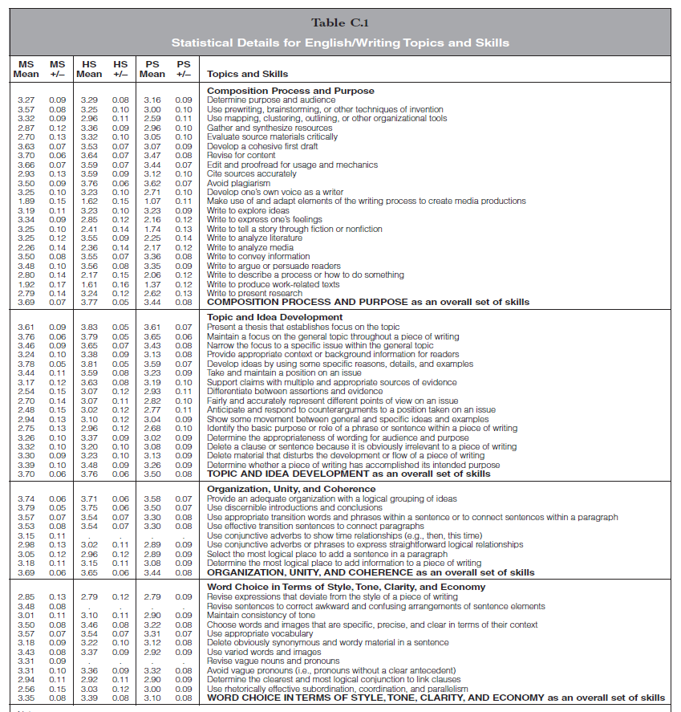
(Mean scores reflect the importance that teachers at each level [MS=middle school; HS=high school; PS=post-secondary placed on each skill, on a 5-point scale from 0 to 4.)

Strategy 3: Build knowledge of the habits of mind that are perceived as most important for college success.

From CWPA/NCTE/NWP’s “Framework for Success in Post-Secondary Writing” (Executive Summary):
The concept of “college readiness” is increasingly important in discussions about students’ preparation for postsecondary education.
This Framework describes the rhetorical and twenty-first-century skills as well as habits of mind and experiences that are critical for college success. Based in current research in writing and writing pedagogy, the Framework was written and reviewed by two- and four-year college and high school writing faculty nationwide and is endorsed by the Council of Writing Program Administrators, the National Council of Teachers of English, and the National Writing Project.
Habits of mind refers to ways of approaching learning that are both intellectual and practical and that will support students’ success in a variety of fields and disciplines. The Framework identifies eight habits of mind essential for success in college writing:
- Curiosity – the desire to know more about the world.
- Openness – the willingness to consider new ways of being and thinking in the world.
- Engagement – a sense of investment and involvement in learning.
- Creativity – the ability to use novel approaches for generating, investigating, and representing ideas.
- Persistence – the ability to sustain interest in and attention to short- and long-term projects.
- Responsibility – the ability to take ownership of one’s actions and understand the consequences of those actions for oneself and others.
- Flexibility – the ability to adapt to situations, expectations, or demands.
- Metacognition – the ability to reflect on one’s own thinking as well as on the individual and cultural processes used to structure knowledge.
The Framework then explains how teachers can foster these habits of mind through writing, reading, and critical analysis experiences. These experiences aim to develop students’
- Rhetorical knowledge – the ability to analyze and act on understandings of audiences, purposes, and contexts in creating and comprehending texts;
- Critical thinking – the ability to analyze a situation or text and make thoughtful decisions based on that analysis, through writing, reading, and research;
- Writing processes – multiple strategies to approach and undertake writing and research;
- Knowledge of conventions – the formal and informal guidelines that define what is considered to be correct and appropriate, or incorrect and inappropriate, in a piece of writing; and
- Ability to compose in multiple environments – from traditional pen and paper to electronic technologies.

Strategy 4: Build an understanding of pedagogies associated with “teaching for transfer”
Ten Tools for Teaching for Transfer

Hugging/Low-Road Transfer: Making the learning experience more like the ultimate applications. Students do and feel something more like the intended applications. | Bridging/High-Road Transfer: Making conceptual connections between what's learned and other applications. This is more cerebral, less experiential. Students generalize and reflect.
1. Setting expectations: Simply alert learners to occasions where they can apply what they are learning directly, without transformation or adjustment. Example: "Remember, you'll be asked to use these pronouns correctly in the essay due at the end of the week." | 6. Anticipating applications: Ask students to predict possible applications remote from the learning context. Example: After students have practiced a thinking skill or other skill, ask, "Where might you use this or adapt it? Let's brainstorm. Be creative." List the ideas and discuss some.
2. Matching: Adjust the learning to make it almost the same experience as the ultimate applications. Example: In sports, play practice games. In drama, full costume rehearsals. | 7. Generalizing concepts: Ask students to generalize from their experience to produce widely applicable principles, rules, and ideas. Example: After studying the discovery of radium, ask, "What big generalizations about scientific discovery does the discovery of radium suggest? Can you support your generalizations by other evidence you know of?"
3. Simulating: Use simulation, role playing, acting out, to approximate the ultimate applications. Example: Simulated trials, simulated senate discussions, etc., as preparation for understanding and participating in government as a citizen. | 8. Using analogies: Engage students in finding and elaborating an analogy between a topic under study and something rather different from it. Example: Ask students to compare and contrast the structure of the human circulatory system with the structure of water and waste services in a city.
4. Modelling: Show, demonstrate rather than just describing, discussing. Example: A math teacher demonstrates how a problem might be solved, "thinking aloud" to reveal inner strategic moves. | 9. Parallel problem solving: Engage students in solving problems with parallel structure in two different areas, to gain an appreciation for the similarities and contrasts. Example: Have students investigate a (nonsensitive) problem in their home environment and a study problem in school, using the same problem solving strategy. Help them to draw out the parallels and differences.
5. Problem-based learning: Have students learn content they are supposed to use in solving problems through solving analogous kinds of problems, pulling in the content as they need it. Example: Students learn about nutritional needs under different conditions by planning the menu for a desert trek and a long sea voyage, getting nutrition information out of their texts and other sources as they work. | 10. Metacognitive reflection: Prompt and support students in planning, monitoring, and evaluating their own thinking. Example: After a quiz or indeed any thought-demanding activity, have students ask themselves, "What went well, what was hard, and how could I handle what was hard better next time?"

This document is from learnweb.harvard.edu/alps/thinking/docs/10tips.doc and is based on How to Teach for Transfer (Robin Fogarty, David Perkins, and John Barell, Palatine, IL: Skylight Publishing, 1992.)

Strategy 5: Develop an articulate stance against pressures for lock-step alignment between high school and college.

Fanetti, Bushrow, and DeWeese: “We think of college as the place where students develop “their own voices,” where they find the confidence to “think for themselves” and “outside the box.” Students are confronted with alien ideas and challenged to articulate and advocate for their own. Whether one thinks of the academy as a bastion of openmindedness and free thinking or as a hotbed of liberal brainwashing, it is virtually universally understood to be a site for abstract analysis and critical thinking—skills resistant to large-scale, objective standardization. Instead of the rigid rules of test preparation high school students learn, college students learn that with each course and instructor come entirely new expectations, expectations that often contradict those of previous instructors. High school students learn to follow a specific set of rules; college students learn that there are no rules—or, better, that the rules change daily. Instead of the detailed rubrics, repeated drilling, and objective testing they knew in high school, college students find themselves largely autonomous and left to figure out what’s expected of them on their own.”
Additional reading

ACT. National Curriculum Survey, 2009: http://www.act.org/research/policymakers/pdf/NationalCurriculumSurvey2009.pdf
Joanne Addison and Sharon James McGee. “Writing in High School/Writing in College: Research Trends and Future Directions.” College Composition and Communication 62.1 (Sept. 2010): 147-179.
Anne Beaufort. College writing and beyond : A new framework for university writing instruction. Logan, UT: Utah State University Press, 2007.
Doug Brent. “Transfer, Transformation, and Rhetorical Knowledge: Insights from Transfer Theory.” Journal of Business and Technical Communication 25.4 (2011): 396-420.
Andrew DelBanco. “College at Risk.” The Chronicle of Higher Education. Feb. 26, 2012. http://chronicle.com/article/College-at-Risk/130893/
Doug Downs. “Teaching First-Year Writers to Use Texts.” Reader, Fall 2010: 19-50.
Susan Fanetti, Kathy M. Bushrow, and David L. DeWeese. “Closing the Gap between High School Writing Instruction and College Writing Expectations.” English Journal 99.4 (2010): 77–83.
Dan Fraizer. “First Steps Beyond First Year: Coaching Transfer after FYC.” Writing Program Administration 33.3 (Spring 2010): 34-57
Mary Goldschmidt. “Marginalia: Teaching Texts, Teaching Readers, Teaching Writers.” Reader, Fall 2010: 51-69.
Nelson Graff. “Teaching Rhetorical Analysis to Promote Transfer of Learning.” Journal of Adolescent & Adult Literacy 53.5 (Feb. 2010): 376-385.
Ken Hjortshoj. The Transition to College Writing. Boston, MA: Bedford/St. Martin’s, 2001.
David Perkins & Gavriel Salomon. The science and art of transfer. (1990) http://learnweb.harvard.edu/alps/thinking/docs/trancost.htm
David Vincent. “Literacy Literacy.” Interchange 34:2/3 (2003): 341-357.
Elizabeth Wardle. “‘Mutt Genres’ and the Goal of FYC: Can We Help Students Write the Genres of the University?” College Composition and Communication 60.4 (June 2009): 75-789.
Jennifer Wells. Millennials Strike Back: Students’ Reports Of Knowledge Transfer from High School to College. Dissertation. Indiana University of Pennsylvania, 2011.
Jennifer Wells. “They Can Get There from Here: Teaching for Transfer through a Writing about Writing Course.” English Journal 101.2 (2011): 57-63.
WPA/NCTE/NWP. Framework for Success in Postsecondary Writing. January 2011. http://wpacouncil.org/framework
Wyoming P-16 Education Council/Wyoming School-University Partnership. “Features of Secondary School and Postsecondary Entry-Level Writing Courses.” 2009. http://www.uwyo.edu/wsup/_files/docs/p-16charts/coursecomp_writing_highres.pdf.

Part IV. Collecting Ideas about Research-Related Literacy
We’re hoping to collect information about educators’ needs and interests regarding research-related literacy (not necessarily related to “college prep” research). We appreciate your willingness to answer the following questions and to share your ideas.

- What level do you teach? K-6 7-9 10-12 college-level other: _____________________

- What are your major objectives when you assign research?

- What challenges do you face when you assign research projects?

- What are the major features of one of a current or representative research project you assign? (purpose, number of sources, interdisciplinary components, research stages/process, type of product(s), citation expectations, etc.)

- What types of session topics would help you improve/revise your research assignments?

- Are you interested in receiving information/reminders about Teaching Writing in Wyoming 2013 (tentatively focused on research literacies in grades 7-12+)? YES NO

- Are you interested in being contacted for follow-up questions related to your/your school’s approaches to effective research assignments? YES NO

Please provide your contact information below.

Name: ________________________________________________________
School/Subject: ________________________________________________
Email address: _________________________________________________

